PHFI USER MANUAL

Purpose
The User manual provides an overview on permissions allotted to Guest user. This manual provides guidelines to Guest user to use the PHFI Clinion EDC system.

Scope
The Scope of this manual is limited to describing the system functionalities, login and request methods.

Guest User
A Guest User can view contents available on the site webpage, view the list of CRDR projects, request access for documents, follow the News and Updates from the URL. Contact Information is also made available for the user convenience.

On load page/Home Page
On loading or on clicking the Home page user will be made available with Header menu containing modules “About us”, “News & Updates”, “CRDR Projects List” and “Contact Us”. Other section of page contains “Using CRDR”, “News & Updates”, “Recent Projects”, “Contact Us” “Other sites Links” and “Quick Links” menus with related information. There is a display picture slide show with various slide information. A “Search Repository” is available to search Study related aspects.
Search Repository
The search repository has a Text box for searching the Keywords related to study. If user has no clue about the study details “Advanced Search” is provided at the same section. On clicking “Advanced Search” and on clicking on “Search Icon” system navigates user to CRDR project list page.
The other columns available in the page are as follows:
USING CRDR
Using CRDR column displays study repository related information. The information feed is given by Super admin user. All the information fed by Super admin can be viewed in this section.
NEWS &UPDATES
The news feed is also done by Super admin user. Both general and study related news can be viewed using this menu. On clicking “Read more” hyperlink at each study, system navigates the user to News &Updates module. Navigated page is discussed in detail under News &Updates module.

RECENT PROJECTS
List of the projects with a hyperlink “Read More” is available in this column. On clicking Read more hyperlink, user will be navigated to CRDR project list module, where the details related to documents uploaded for that study are available. [Navigated page is discussed in details under CRDR Project List module.]
CONTACT US
Contact information is displayed in this menu.
OTHER SITE LINKS
Other site links displays the slides related to other major sites
QUICK LINKS
Quick links navigates user to respective pages to view contents of “Work with us”, “tenders”, “PHFI in the news”, “Brochures”, “Give & Partnerships”, “Financial Information”.
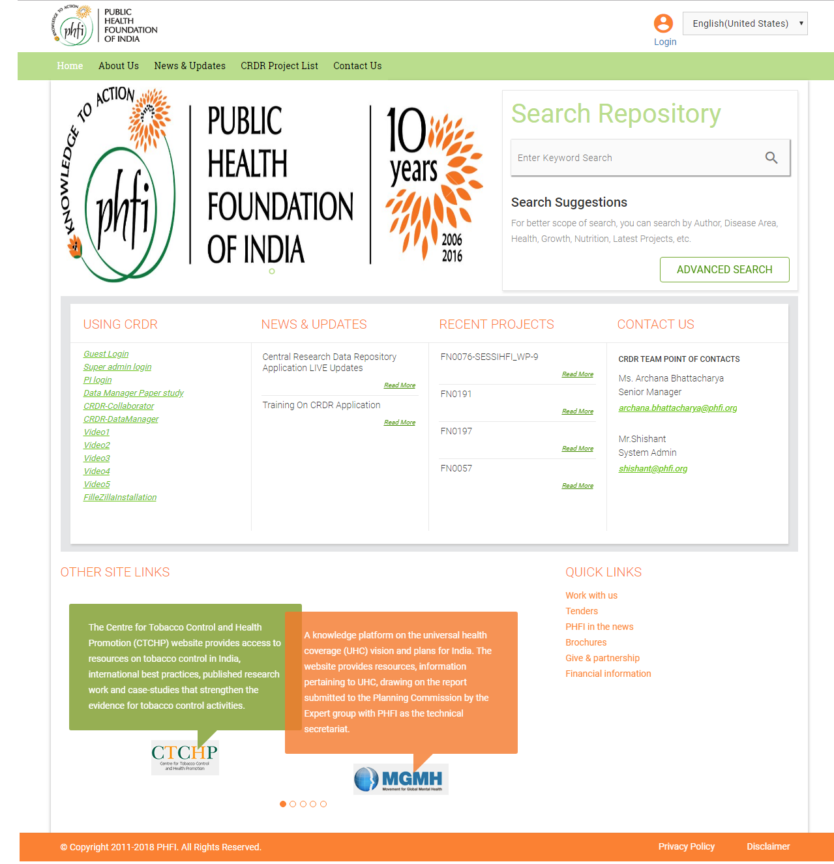
Figure 01: Home Page

About Us
On clicking About Us menu, the details about the company profile can be viewed. Formation, launch and Approach details of PHFI and there are perspectives are given in this page.
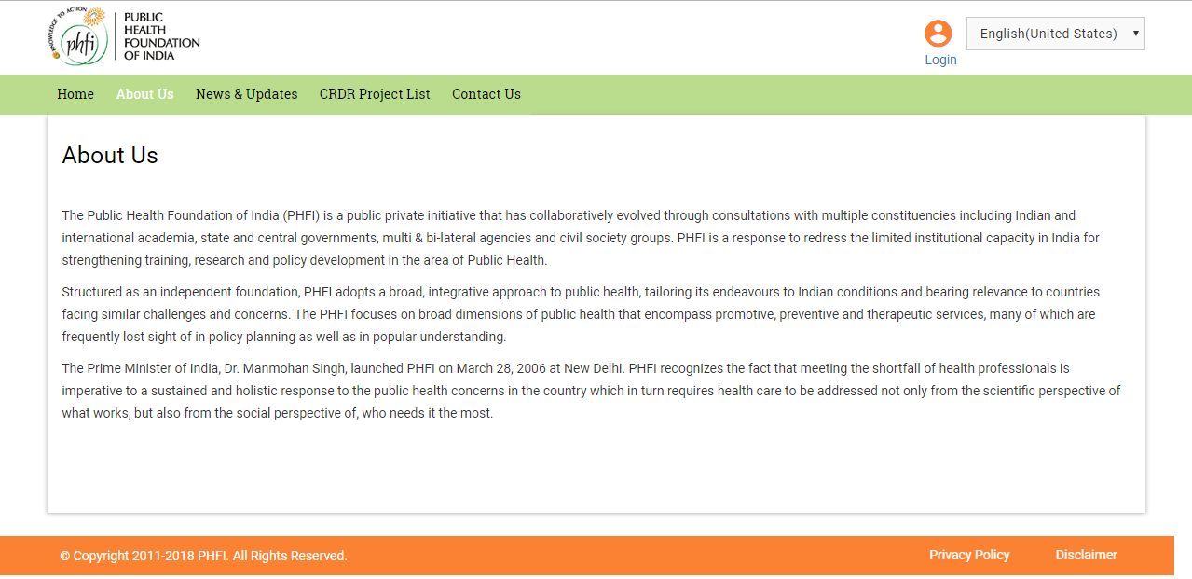
Figure 02: About Us

News &Updates
On clicking this menu, all the news updates uploaded can be viewed. The News feed is given by Super admin user. The Latest News fed are displayed on top. All the Scientific related and Non Scientific News and updates are available in this module. Different News updates are displayed in different sections with a numbering for each. Each section can be Expanded and collapsed to view the details in it. On load the top News section is displayed open, and the further sections can be expanded as per requirement.
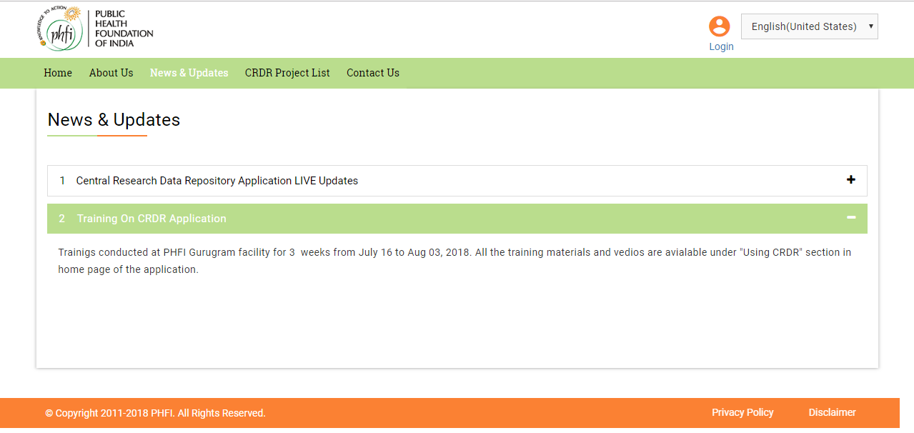Figure 03: News &Updates

CRDR PROJECTS LIST
CRDR projects list will be displayed in this module. The details related to the Ongoing, Closed and public projects can be viewed here. The access to the study can be requested and the guest user can understand the details such as PI details, Study type/ Status and category details.
Search Box
The Search area contains a “Drop down” box and “Text Box” to enter the study details. An “Add icon” is available for an advance search.
- On clicking the drop down box, user will have the facility to select any of the following options “Project Title”, “Project Code”, “Category”, “PI Name”, “Project Status”, “Date Submitted”, “Move to Repository in Last Days”.
- There is a text box with “Enter Data” help text is available, to enter the study related data.
- On clicking “Add Icon” a new set of search boxes will appear along with another drop down with “And”, “OR” and “And/Or” options.
Study List Grid
- Study list grid contains “Title of the Study”, “Category”, “PI Name”, “PIs Email Address”, “Status” and “Actions” details.
- There is a radio button to filter the “Ongoing”, “Closed”, “Public” is available. By default, “All” is selected and all the studies are listed out.
- Page Navigation at the bottom of the page allows to view details listed in different pages.

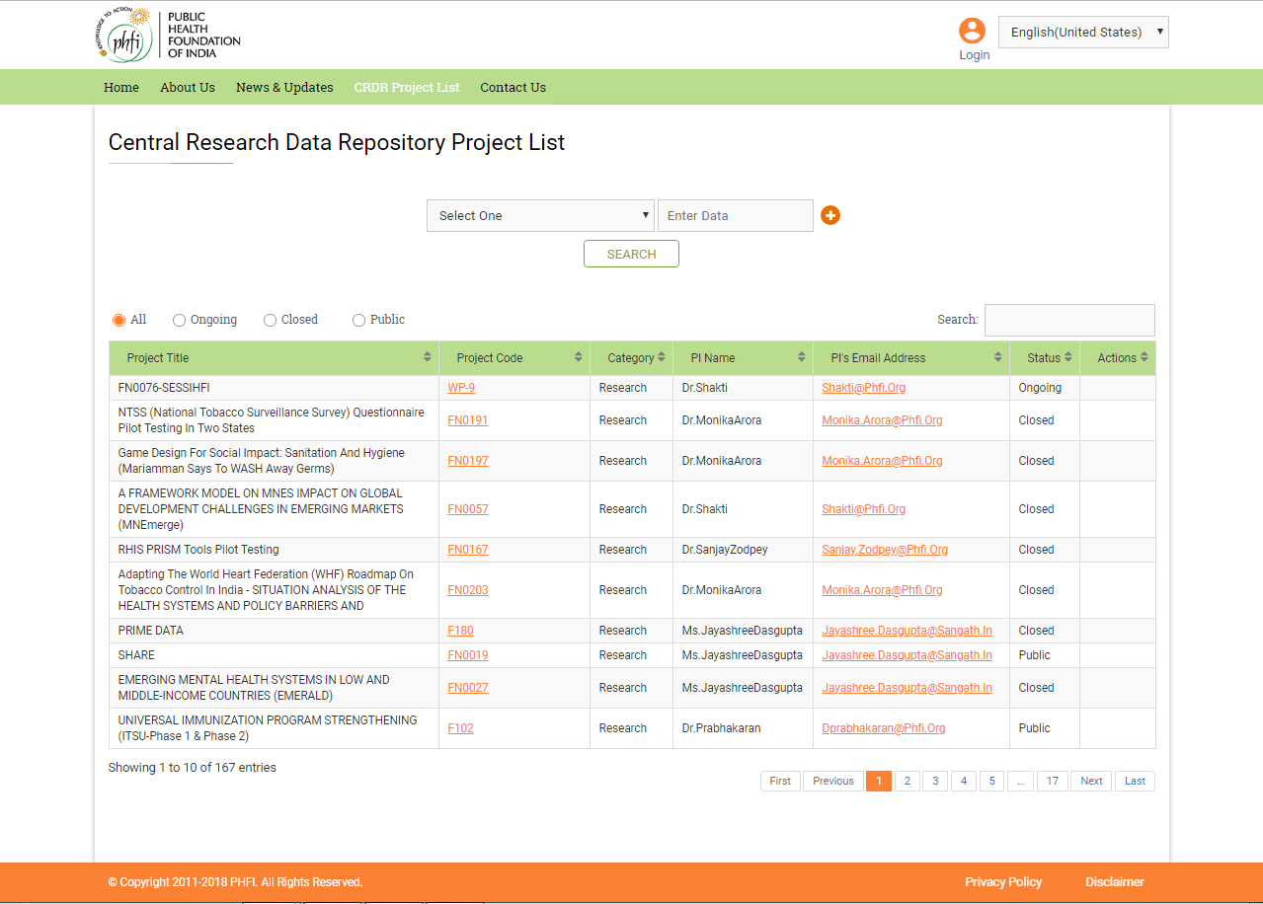
Figure 04: CRDR Project List Page
- The “project Code” is given as a hyperlink in red. On clicking Project Code link, user is navigated to a page where various open documents can be accessed. Study related documents are available in this page. The Related Documents are provided in respective folders at the left hand side of page. All the folders are listed in the left had section of page. On clicking on the folder, user has the list of documents displayed on screen.
- User can select the required document and click on “Move to request” to look in to further folders.
- User can either “Request for Access” for individual documents or place a consolidated request by using “Move to Request” menu.
- Finally, one “Request for Access” can be placed after moving the required documents for request.
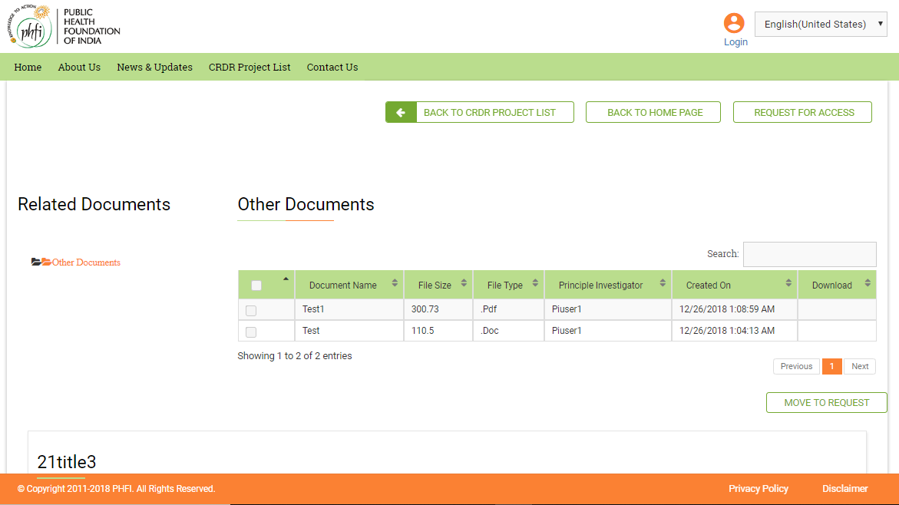
Of all the documents sets access is provide only to public documents. Permissions for the documents can be requested using “Request for Access” menu available on the top of page. [Note: This form is same as that available on CRDR Projects List page. In detail description is provided in further section of this manual]
- Other menus available at the top of the page include: “Back to CRDR Project List” to navigate to list page and “Back to Home page” to navigate directly to Home page.
- At the bottom of page Read me file details are available.
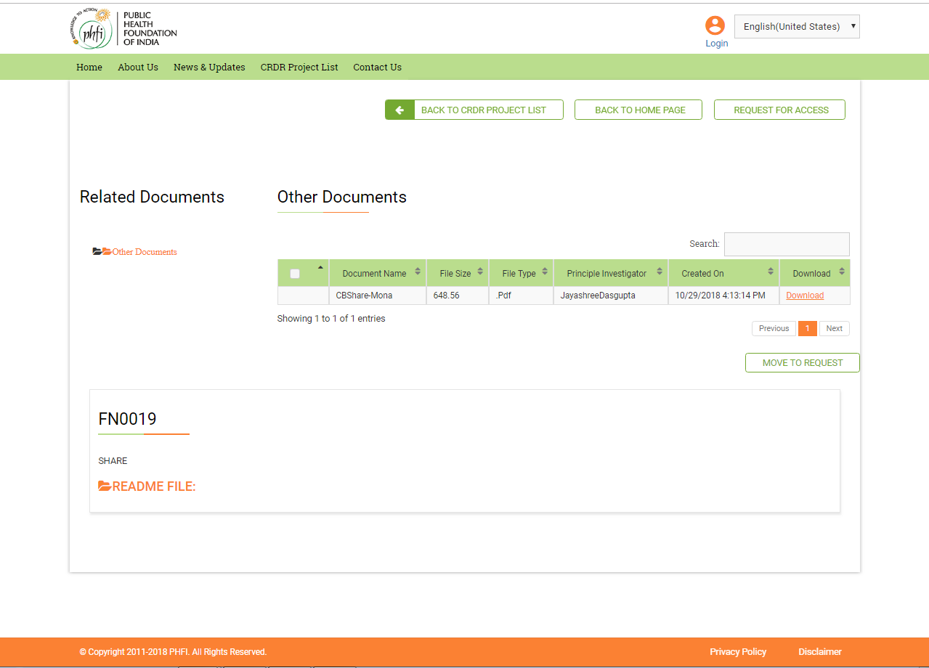
Figure 05: Documents page
Request for Access
For all the public studies, Guest user can “Request for Access”. Once the Request for access is approved he/she will become the signed user and gets permissions with application.
- On clicking “Request for Access”, a pop up request form will appear on the screen with details to be filled for
- Your Name
- Email ID
- Mobile
- Comments
- Upload File
And Submit or Clear options. The Request Form can be downloaded using “Click here to Download” option. The downloaded Request Access Form has fields to be filled up and this can be uploaded using “Upload File” menu.
- Once the Request Form is submitted, the request is sent to respective PI for approval. The PI who created the study for which access is requested will receive the approval request.
- Once the Request for Access is accepted, the Guest user becomes the part of application and will no longer termed as “Guest”. He will have all the permissions as “Research Associate”.
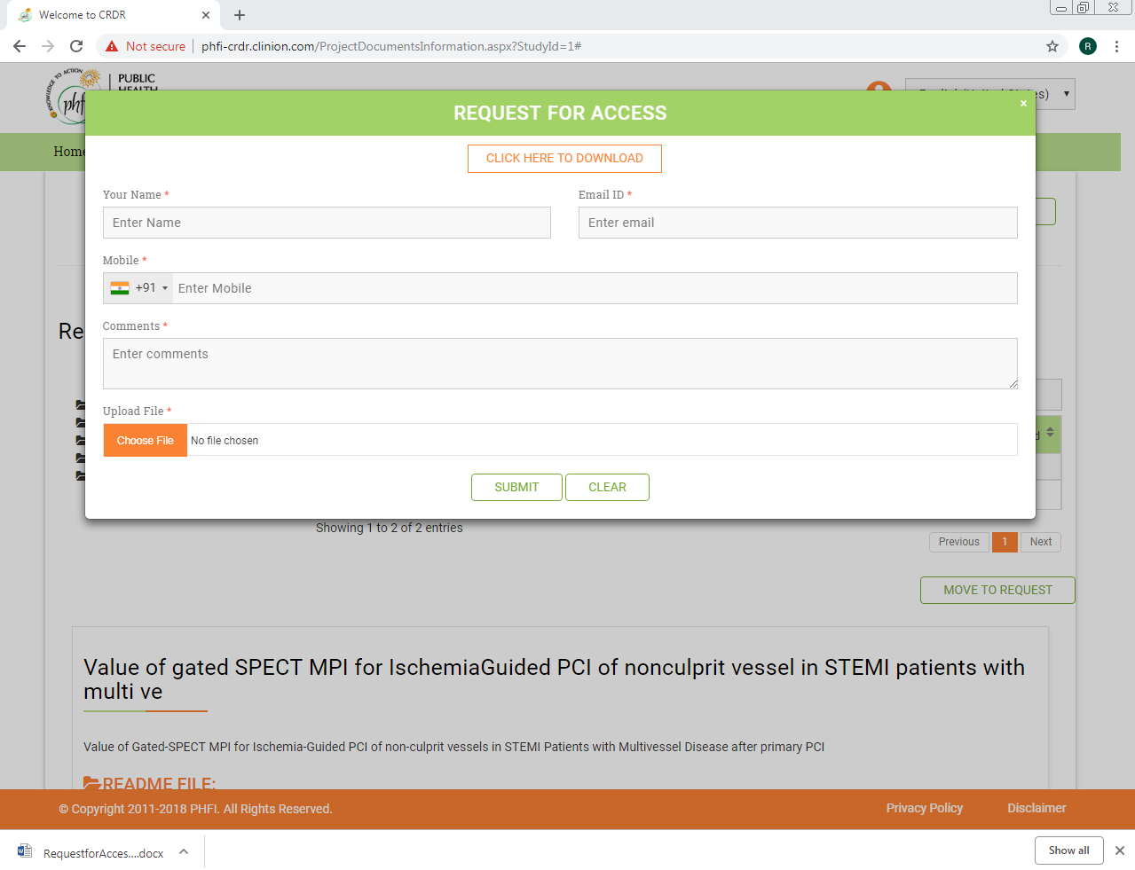
Figure 06: Request for Access Pop up
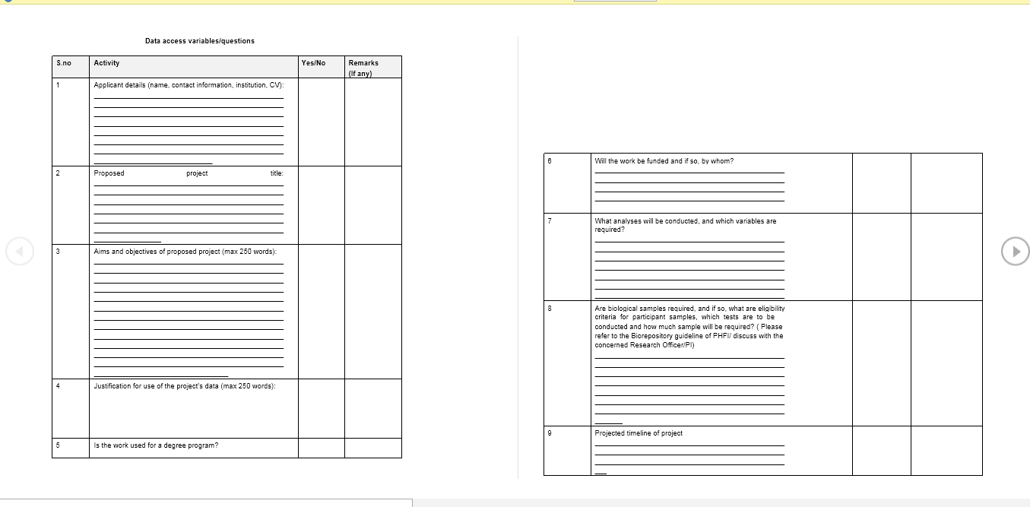
Figure 07: Downloaded Request form

Contact Us
Contact Us module has the details how to approach the Public Health Foundation in all the possible ways such as Location, Email and Telephone details.
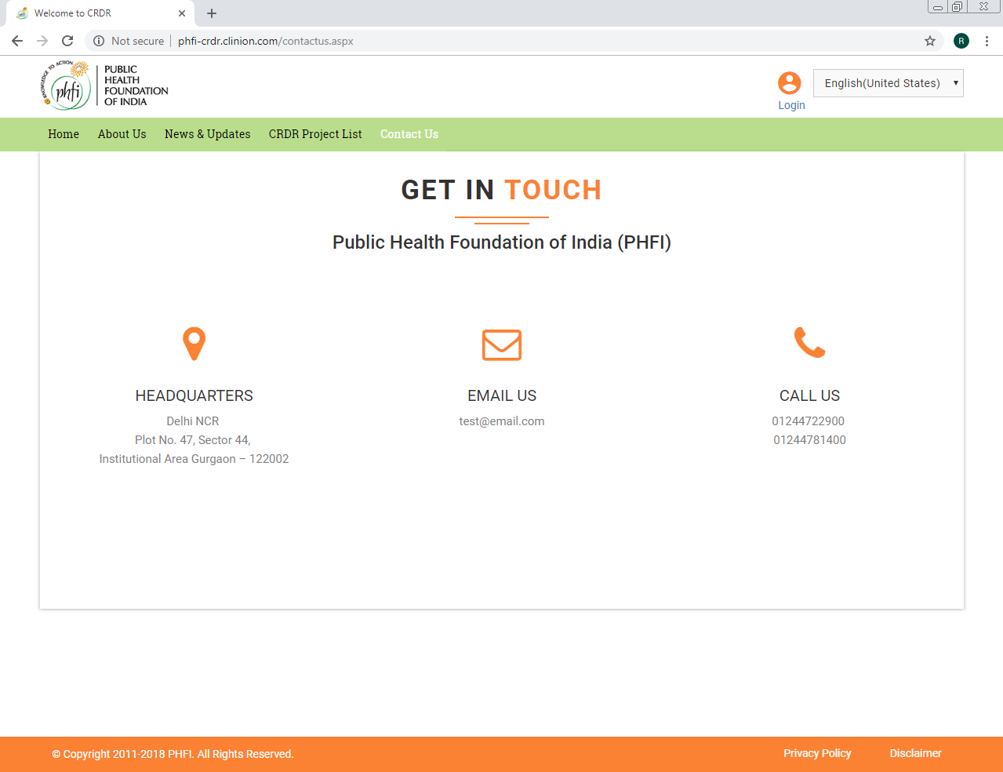
Figure08: Contact Us Page

